DIGITAL MTC PASS USING PWA

¹Mrs.SUBASHINI T

*¹Assistant Professor,Associate Professor Department of CSE, Velammal Engineering College,Chennai,India.*

[subhatanish@gmail.com](mailto:subhatanish@gmail.com)

²SRIRAM B, ²PRAVEENKUMAR RA, ²DIVYA PRAKASH

*²UG Scholar, Department of CSE, Velammal Engineering College,Chennai,India.*

[sriramb2k@gmail.com](mailto:sriramb2k@gmail.com) , [praveen2005kumar@gmail.com](mailto:praveen2005kumar@gmail.com) , [divyaprakash473@gmail.com](mailto:divyapraksh473@gmail.com)

***Abstract*—** As digital Technology dominates the current situation, the objective of this app is to provide the latest digital way of using MTC Pass which allows commuters to mark their trip by scanning QR codes to monitor their travel. With the help of the Progressive web app, bus commuters can digitally mark their trip by just scanning a QR code. Instead of carrying an MTC card, commuters can install this app and mark their trip digitally by scanning the QR Code. Also, bus commuters can check the dashboard provided by the app to see the number of trips taken on a respective day with the boarding and destination point. This app maintains a database that stores the commuter's trip details and updates the trip count every day. This app also provides an option to renew the current bus pass. Once renewed, this app starts monitoring the trips till the next renewal. For security purposes, commuters must log in to the app with their mobile number/ bus pass id with their Date of Birth. The login credentials are verified with the details provided at the time of applying for a bus pass.

***Keywords***— **Web App , MTC Pass , QR Code Scanning, trip**

**1. INTRODUCTION**

As digital technology dominates the current world, every sector has been digitized. Still mtc bus passes are carried manually and trips are marked manually by the bus conductor. Carrying bus passes manually has more probability of missing it. As well as availing and renewing bus passes are done manually at the depot or by school admin. Also, bus fares are calculated manually by the depot officer at the time of availing bus pass.

So, “Digital MTC Pass using PWA” is a web app which focuses on digitizing the mtc pass (epass). It provides a digital pass in which commuters can login with their name and mobile number. Once logged in, commuter is redirected to dashboard, where commuter is provided with two functionalities.Commuter can scan the respective route qr code and mark their trip in the epass. If the bus pass has expired, then commuters can renew the bus pass online by clicking the renew button from the dashboard. Once renewed, commuters can use epass. For the first ten days of the month, the renew option is available and commuters can renew the bus pass. In addition, Commuters are provided with the option of viewing their trip details, viewing profile etc… This application also provides an option to buy seasonal passes. For seasonal passes, commuters can view their trip count in the dashboard. Also, can view all the trips taken with the respective pass in the trip details page. Bus pass registration is done by the depot officer, and based on the route, the fare is calculated automatically. If the invalid qr code is scanned, then the application will not mark the trip and throws an error message. So, this project provides a digital platform to avail, renew and use digital bus passes.

**1.1 OBJECTIVE**

The main objective is to digitalize the way of using MTC Bus passes. Instead of using Bus pass as a card and waiting in a large queue for registering and renewal of those cards, we created a solution that allows card users to use the same bus pass in a digitized way with help of an App. That allows the user to buy and renew bus passes on their fingertip. And can also scan to mark passes instead of those native unvalidated tick’s. With help of PWA the size of the app can be reduced.

**2 LITERATURE SURVEY**

**[1]** V, Pandimurugan & R, Jayaprakash & V, Rajashekar & K, Yogeshwar has presented a paper on “Smart Buspass System Using Android” which provides an online platform to avail and renew bus passes. It Focuses on Monthly, Student & Senior citizen pass. All the documents submitted will be verified by the School/ College Admin or Depot officer. Once verified, the Bus pass will be sent to the registered email id. Watermark is added into the bus pass to avoid duplicate passes.

**[2]** Sim Liew Fong; David Wui Yung Chin; Rabab Alyaham Abbas; Arshad Jamal; and Falah Y. H. Ahmed presented a paper on “Smart City Bus Application With QR Code : A Review” which mainly focuses on buying tickets online and payment can be done by scanning the QR Code. This paper keeps track of the live location of the bus and displays the bus routes using google maps api.

**[3]** P.Sharmila, A.Ponmalar, and Skanda Gurunathan R presented a paper on “Bus Pass and Ticket automation System” which develops an app to avail and renew bus pass through online. A QR Code will be pasted on the bus and by scanning that, commuters can buy tickets via the app. It also notifies the commuters on expiration of the bus pass.

**[4]** N. Krishnammal, Ramya C, Shiva Ganesh K, and Shrenidhi R presented a paper “Efficient Bus Pass Generation and Authentication using QR Code” which provides an application to avail and renew bus passes. This application has two portals, Admin and passengers portal. In passenger login, they can avail or renew bus pass by scanning a QR Code. Admins can view the bus pass details by just scanning through their device. The documents uploaded by passengers will be verified by the School Admin for student bus passes to reduce the workload of bus conductors and to avoid using duplicate bus passes.

**3 EXISTING SYSTEM**

• **Not Wear and Tear:** Native cards are not wear and tear, since we use passes for a year, they end damaged a lot. The chances of losing is high

• **Manual Registration**: Bus Commuter have wait in huge crowd for buying travel as you like Passes

• **Manual Renewal Process** : Existing system requires a lot of paperwork. Each commuter have to wait for long hours to renew their passes

• **Unvalidated Pass**: Most of the time when pass holders mark their ride they are un validated.

• **Manual entry of rides**: All the rides marked are manual in every type of passes and no records for rides are maintained

**3.1** **DISADVANTAGES IN EXISTING SYSTEM**

* Time Consuming
* Manual Fare Calculation
* Manual Renewal Process
* Manual entry of rides

**4. PROPOSED SYSTEM**

* **Economical Feasibility:**

The app is developed with a motive to increase the business save time by providing a digitalized way for the users to use the MTC Pass. Marking of Trip , Renewal and Buying Bus passes are made easy.

* **Technical feasibility**

The technical requirement for the app is economic and it just requires a latest version of the browser and Camera permissions. Commuter ride is marked and added to the database with help of PHP. To mark the ride the user need to scan the QR Code, with help of this QR code his/her ride is validated before marking or adding into the DB

* **Behavioral Feasibility**

The app has an attractive user interface and lite weight. One single app takes care of necessary requirements. Different types of users , Marking and Viewing of user rides, Buying certain types of Passes and Renewal of those passes are made in one whole app.

* **Time Efficiency**

With help of this App renewal and buying of certain passes are made easy. Renewal of Commuter and Student pass can be done just by clicking a button. And people can buy ₹50 and ₹1000 passes in the app itself

* **Prevents Illegal use of Pass**

Since marking of passes are done by scanning QR code, Validation can be done. If user gets into wrong bus and tries to scan an error will be thrown, by this way illegal scanning can be prevented

**4.1 ADVANTAGES OF PROPOSED IDEA**

* Saves Time
* Minimizes Crowding
* Enhances Business Profit
* Inculcate social distancing
* Provides Comfort Ordering

**5.SYSTEM MODULE**

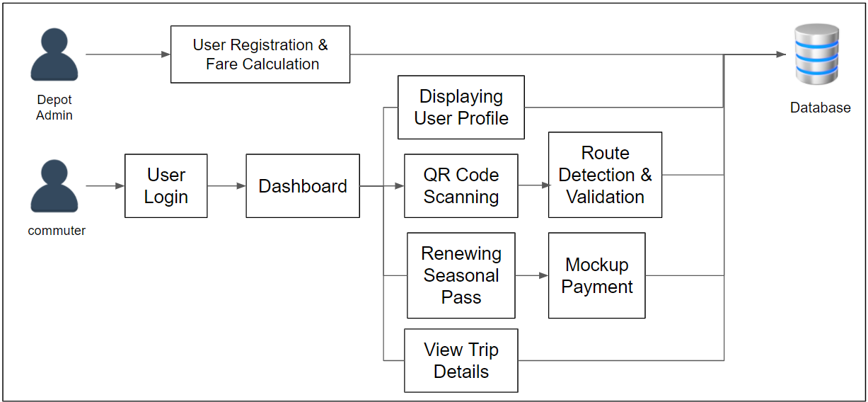

Figure 5.1 - Architecture Diagram

**5.1 MODULES**

* Registration with Fare calculation
* Dashboard
* College or Commuter pass
* Travel as you like pass
* QR Code Scanning
* Route detection & checking
* Mockup payment gateway
* Renewal process

**5.2 MODULES DESCRIPTION**

* **Registration with Fare Calculation:**

A commuter or a college student can register their pass in the registration portal. A username, the Mail address and phone number and their type of Pass is connected.

MTC pass include 2 types:

1. One way

2. Two way

Once the user enters the details in the registration portal the site automatically calculates the amount to be paid for pass. The fare is determined by the number of buses, Number of Stages and Type of user (college or Commuter).

This fare calculation has 3 test cases

1) One Way - A direct route where the user can reach is Destination in a single bus and in a Single route

a) The Fare is calculated based on the number of stages in between the Starting Point and Destination

b) If this route is covered by any other different Bus, then the fare is the one maximum number of stages

2) Two Way – Here the commuter needs to take two buses in order to reach his Destination Point

a) The Fare is the calculated sum of the number of stages in between the Starting Point and Destination of Two buses

b) If any one of the routes is covered by any other buses, then the bus which has maximum stages to reach the Destination is taken into account

Once the fare is calculated then the Portal redirects to a Payment Gateway. A Mail will be sent as Acknowledgement with receipt to the user.

* **Dashboard**

Every user login to their dashboard with Name and Phone Number. In Dashboard the user can scan the QR code to mark their ride. They can also see their number rides they took which differ from each user

* **College or Commuter pass**

This pass is issued for pre-registered users only. They are two Different type of these passes

1. One – Way : User can scan up to two count which they ride twice up and down in the bus which travel to their route

2. Two – Way: User can scan up to four count which they ride twice up and down in different bus which travel to their respective routes

* **Travel as you like pass**

This Pass can be bought any time, Usually in these types of passes user records are not stored. They come with 2 Types

1. Day Pass: User have unlimited count to any destination valid for 24 hours

2. Month Pass: User have unlimited count to any destination valid for 30 days

Users can buy this Pass , by clicking Buy Pass at any time. This redirect to payment portal where user can pay through Credit / Debit card or Online Payment

* **QR Code Scanning**

Every bus commuter must scan the QR code attached to the MTC bus.Once scanned, the trip count gets updated in the database for monitoring purposes. Updation of count plays an important role, because it is used to verify whether the user has exceeded the quota.

Every scan is stored in the Database the users can see it by clicking the Table button. The minute the user scanned, the time of scanning , Date ,Starting point and Destination Point are stored

A pure javascript QR code reading library. This library takes in raw images and will locate, extract and parse any QR code found within. This allows it to just as easily scan a frontend webcam stream, then data scanned is sent for validation

* **Route detection and checking**

In the previous module we saw that QR code data is sent for validation. This QR code validation differs from different types of Users.

It checks whether it is a QR code Designed for Bus or not. The data received is the Bus number. When Scanned this number returns an array of Stages. If the Starting point and Destination of the user matches with the array of Stages then the user ride is marked.

* **Mockup payment gateway**

This gateway resembles the real payment , but instead real money a mockup money is transferred. The Fare , Name and Mail address is displayed during this payment. A Mockup Receipt is sent to users mail address , with help of inbuilt smtp support in PHP.

* **Renewal Process**

Renewal Process in this app is applicable only for College and Seasonal pass users.

Users Can Renew by clicking on the renew button that appears only at 1st of every month till 10th of every month. The Renewal process as following testcase

1. Users who renew in between 1st and 10th of every month. After renewing their pass validity will be updated to next month till 10th

2. Users who fail to renew the pass, their Scan to Mark will be revoked temporarily until they renew

Onclick the renew button user will be redirected to payment gateway and After payment the MTC Pass will be renewed.

**6.IMPLEMEMTATION RESULTS**

* **Login Page**

Contains login form for authentication purpose.A Commuter can login into the app using their mobile number and Name. Also , commuter can buy monthly / daily pass from this page

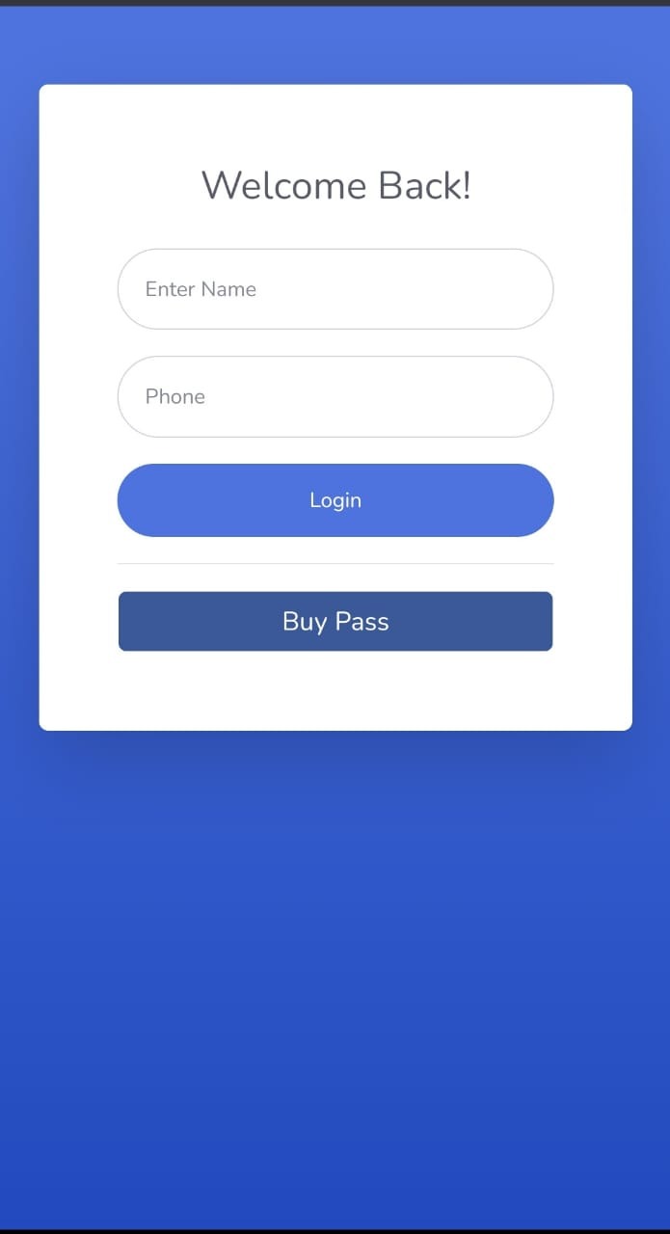

Figure 6.1 - Customer’s Home Page

* **Dashboard:**

Option to Scan the qr code Option to renew the bus pass Displays the count of trips takenDisplays the route details - Boarding point & Destination point

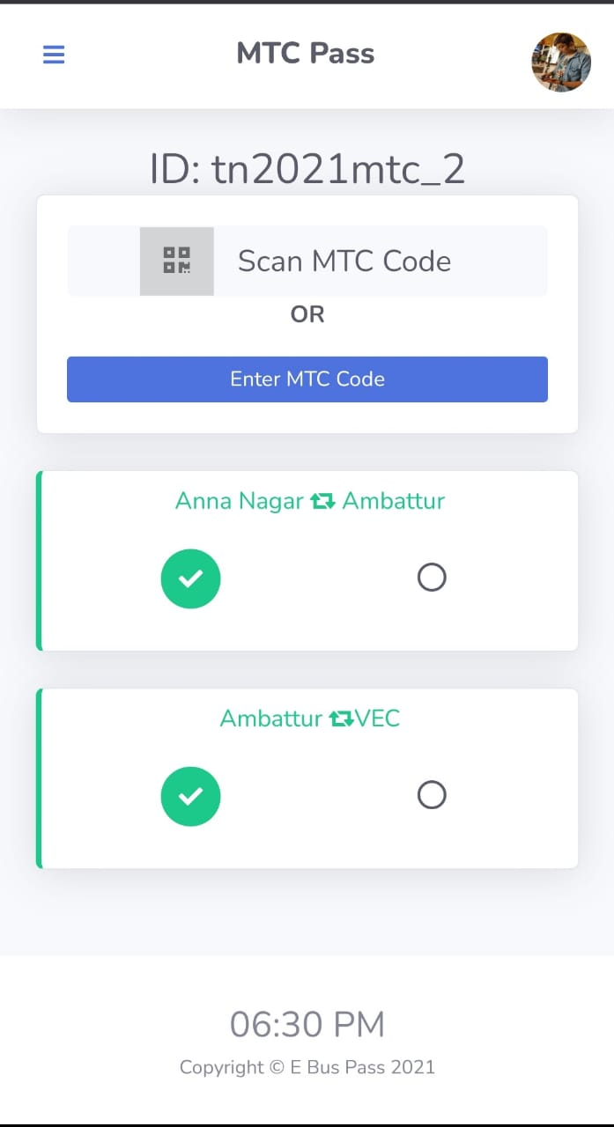

Figure 6.2 -Shop Page

* **QR Code Scanning**

Marking the trip by scanning the QR Code QR Code contains the MTC bus number. Scanning other route Qr Code will throw an error.

.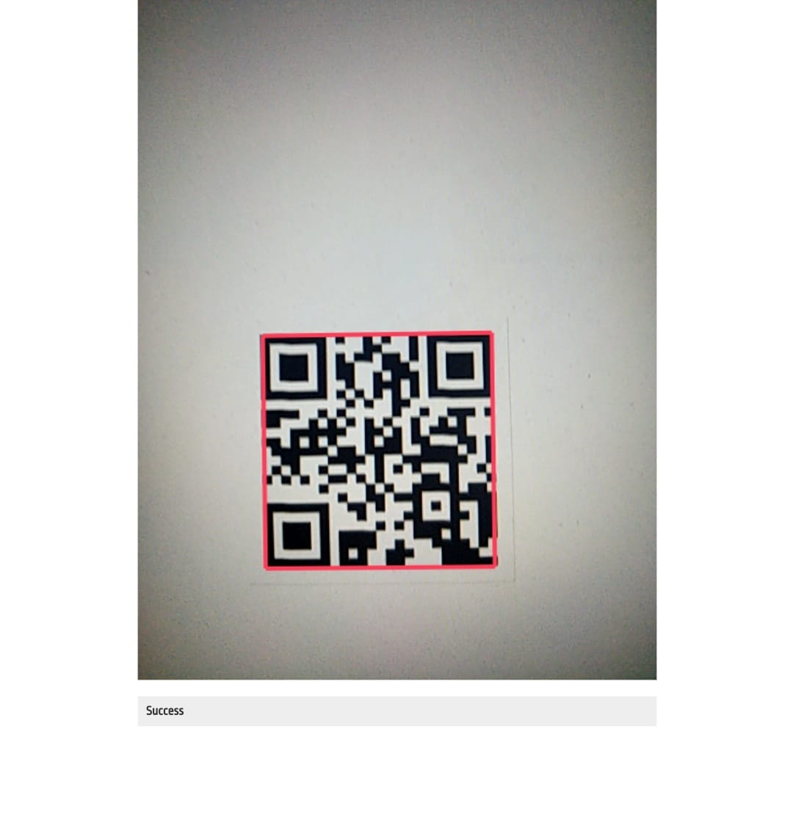

Figure 6.3 - Products Page

* **Route Detection and Validation**

Validates whether the commuter scans the Qr belongs to his bus pass route Throws alert, if commuter scans the Qr of different route Otherwise, mark the trip in epass

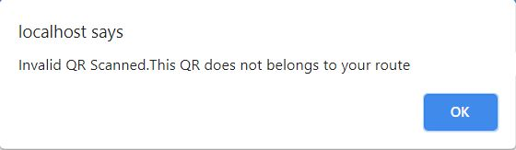

Figure 6.4 - Shopkeeper Portal

* **Trip Details**

Displays the following trip details Route, Date of the trip, Time when trip is marked.

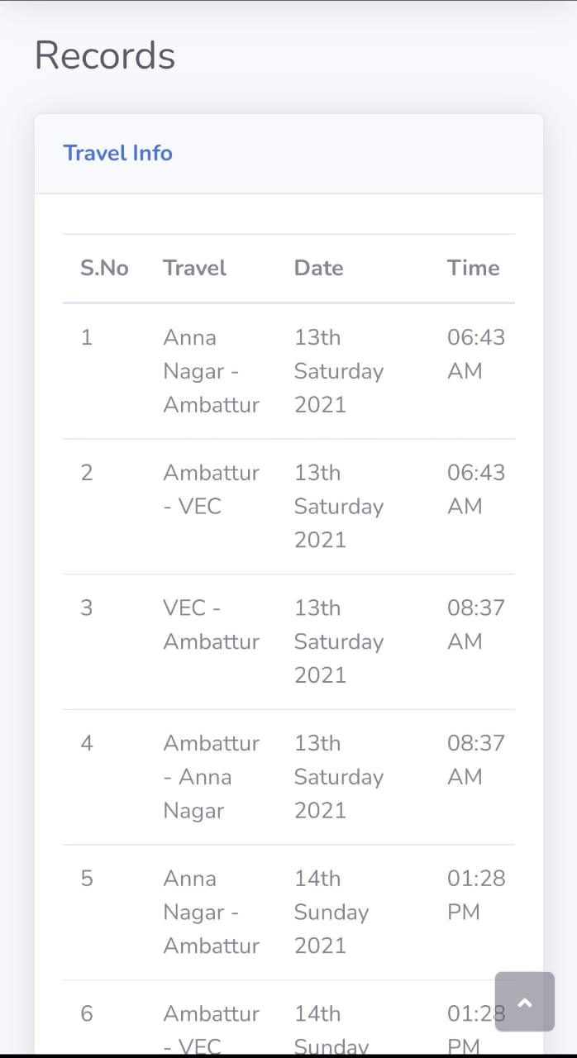

* **Renewal Process**

User can renew from the 1st day of the month. Once the bus pass expired, user can scan only if they renew. Once renewed, user can use the bus pass

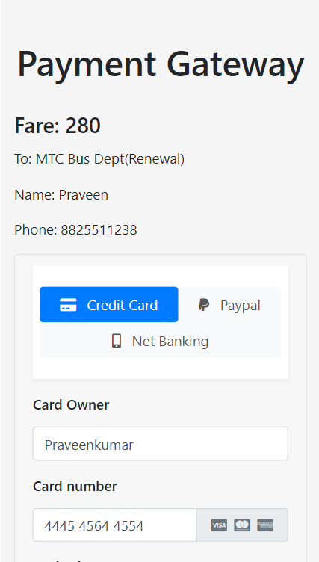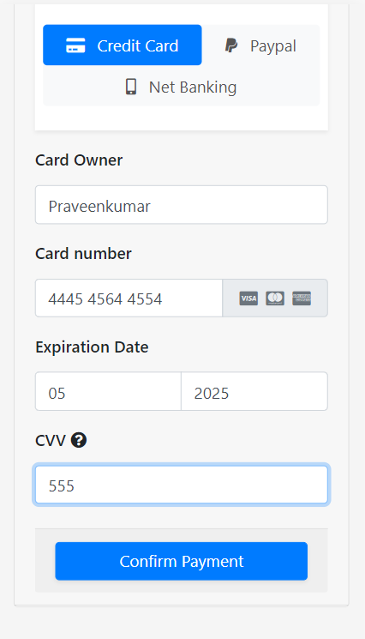

* **Registration and Fare Calculation**

Fare is calculated based on the number of stages between the Boarding and Destination Point

In case of more routes, fare is calculated with the route which has maximum number of stages

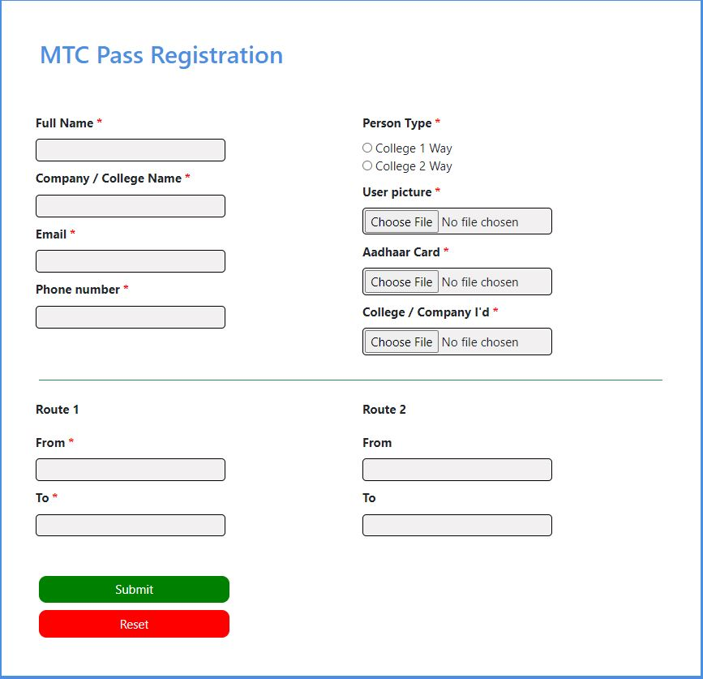

**7. CONCLUSION**

This project “Digital MTC Pass using PWA” uses the concept of Progressive Web App to make the application more user - friendly for the bus commuters. This provides the easy platform to buy and renew the MTC pass.

This reduces renewal time and improves the way of using MTC Passes. Instead of buying or using different passes for different needs , This single app takes care of all types of Bus Passes and their Renewal Process.

**8. FUTURE ENCHANTMENTS**

**1)Single PVC Card can be created:**

With help ajax we can change available products before the data is submitted. This means that the particular division which consists of the availability of products will be updated every 5 milliseconds.

**2) Bus pass process for Handicap**

In the future,shopkeepers are provided with an option of uploading the images of their fresh fruits,vegetables etc...

**9. REFERENCES**

[1] V, Pandimurugan & R, Jayaprakash & V, Rajashekar & K, Yogeshwar, “Smart Buspass System Using Android” in Conference on Innovations in Information and Communication Technology (ICIICT), Chennai, India, 2019

[2] Sim Liew Fong; David Wui Yung Chin; Rabab Alyaham Abbas; Arshad Jamal; Falah Y. H. Ahmed, “Smart City Bus Application With QR Code : A Review”, 2019 IEEE International Conference on Automatic Control and Intelligent Systems (I2CACIS), 29th June 2019

[3] P.Sharmila ,A.Ponmalar, Skanda Gurunathan R, “Bus Pass and Ticket automation System” , International Journal of Computer Engineering In Research Trends , Volume 3, Issue 8, August-2016.

[4] N. Krishnammal, Ramya C, Shiva Ganesh K, ShrenidhiR, “Efficient Bus Pass Generation and Authentication using QR Code”, International Journal of Innovative Technology and Exploring Engineering (IJITEE) ISSN: 2278-3075, Volume-9 Issue-7, May 2020